Hello Everyone,

I am pleased to announce that **“Google Retail Search (GRS) Tail Queries”** changes have been released in to production after a successful AB test!

The test version with the new GRS service outperformed the control, bringing in an estimated **+$29.57MM ($102.3MM Annualized with COVID Traffic)** in incremental revenuewith **+8bps** (3%)increase in conversion (CVR) and a slight lift to average order value (AOV)

We also saw positive impacts to Revenue per Visit (RPV) with an increase from **$6.62** to **$6.83** (3.22% lift) and a substantial decreased in null rate percentage (NRF) from **3.66%** to **1.07%** (-2.59% drop) compared to the control.

**Customer problem:**

* One of the biggest challenges of online search is how to handle long-tail queries or searches that occur less frequently. Frequent queries, also known as head queries, are easier to handle largely because their intent is evidence by the abundant click-through data (query logs) captured from our customers.
* Long-tail queries have little historical data to rely on, which makes it difficult to be learned by ranking algorithms. These searches are typically longer or more specific and customers are more likely to use these when they’re closer to a point-of-purchase. However, based on the current conversion rate being capture for these queries, indicates and that customers are not seeing the results they want.

**Solution:**

* To improve the customer experience for these types of queries, shoppers will now be given improved results designed by incorporating google retail search algorithm, customer interactions/signals and Lowes product data.
* We also implemented analytics tagging to track the performance of these specific query types both during and after the A/B test, but also as a mechanism to identify areas for improvement.

**Next Steps:**

* The team will continue to improve the current implementation as necessary, so we expect to see additonal improvements in the coming days to weeks.
* We are also working on developing an method to test our current left navigation filters against this new service for our head/high volume search queries.
  + Target Test Date – mid Q4

AB test report can be viewed here: <https://tools.lowes.com/confluence/pages/viewpage.action?pageId=203382698>

**Special Thanks***:*

This incredible improvement for our shoppers and the overall search experience would not have been possible without collaboration across multiple teams and individuals who worked tirelessly to deliver this new feature. We can’t thank you all enough for your hard work but we can recognize you here!

*Maninesan Ramanathan, Aneesh Kurudamannil, Ganesh Selvaraj, Krishnamohan Medamanuri, Alok Pathak, Kumaran Ravichandran, Amy Yu, Vinod Kumar, Devesh Kumar, Sanjay Sudhakar, Raghuprasanth Ravichandran,* *Ajith Kodakateri Pudhiyaveetil, Anoop Purandaran, Ashley Barber, Mike de Boer, Israel Caines, Greg Johnson, Chris Murdock and our partners at Google for all your hard work on getting this feature developed, tested, delivered out to our customers! And thanks to our leadership team  -  Suresh Kodichath, Darshan Nagaraja, Vasanth Baburaj and Ravi Sambhu for all their continued support.*

***Note:****Above numbers based on Finance team evaluation.*

|  |
| --- |
|  |
| Before GRS V1.0After GRS V1.0 |

|  |
| --- |
|  |
| Before GRS V1.0After GRS V1.0 |

* [Skip to content](https://tools.lowes.com/confluence/display/DSH/Computer+Vision+Use+Cases#title-heading)
* [Skip to breadcrumbs](https://tools.lowes.com/confluence/display/DSH/Computer+Vision+Use+Cases#breadcrumbs)
* [Skip to header menu](https://tools.lowes.com/confluence/display/DSH/Computer+Vision+Use+Cases#header-menu-bar)
* [Skip to action menu](https://tools.lowes.com/confluence/display/DSH/Computer+Vision+Use+Cases#navigation)
* [Skip to quick search](https://tools.lowes.com/confluence/display/DSH/Computer+Vision+Use+Cases#quick-search-query)

All documents and pages on Confluence are considered Lowe's Confidential unless otherwise stated

[Linked Applications](https://tools.lowes.com/confluence/display/DSH/Computer+Vision+Use+Cases#app-switcher)

# [Confluence](https://tools.lowes.com/confluence/)

* [Spaces](https://tools.lowes.com/confluence/display/DSH/Computer+Vision+Use+Cases#space-menu-link-content)

* [People](https://tools.lowes.com/confluence/browsepeople.action)

* [Glossary](https://tools.lowes.com/confluence/wglossary/view.action)

* [Calendars](https://tools.lowes.com/confluence/calendar/mycalendar.action)

* [**Create**](https://tools.lowes.com/confluence/pages/createpage.action?spaceKey=DSH&fromPageId=200888214&src=quick-create) **[Create](https://tools.lowes.com/confluence/pages/createpage.action?spaceKey=DSH&fromPageId=200888214" \o "Create from template)**
* 
* [Help](https://tools.lowes.com/confluence/display/DSH/Computer+Vision+Use+Cases)

**[9+](https://tools.lowes.com/confluence" \o "Open Notifications (Type 'g' then 'n'))**

Configure

# [Computer Vision Use Cases](https://tools.lowes.com/confluence/display/DSH/Computer+Vision+Use+Cases)

* [Edit](https://tools.lowes.com/confluence/pages/editpage.action?pageId=200888214)
* [Save for later](https://tools.lowes.com/confluence)
* [Watch](https://tools.lowes.com/confluence)
* [Share](https://tools.lowes.com/confluence)

1. [Dashboard](https://tools.lowes.com/confluence/collector/pages.action?key=DSH&src=breadcrumbs-collector)
2. **…**
3. [Computer Vision Roadmap](https://tools.lowes.com/confluence/display/DSH/Computer+Vision+Roadmap?src=breadcrumbs-parent)

[Skip to end of banner](https://tools.lowes.com/confluence/display/DSH/Computer+Vision+Use+Cases#page-banner-end)

* [45 views](https://tools.lowes.com/confluence/spaces/viewtrackerreport.action?key=DSH)

[Go to start of banner](https://tools.lowes.com/confluence/display/DSH/Computer+Vision+Use+Cases#page-banner-start)

[Skip to end of metadata](https://tools.lowes.com/confluence/display/DSH/Computer+Vision+Use+Cases#page-metadata-end)

* Created by [Darshan Nagaraja](https://tools.lowes.com/confluence/display/~danagara), last modified by [Russell LeJeune](https://tools.lowes.com/confluence/display/~rlejeun) on [Oct 22, 2020](https://tools.lowes.com/confluence/pages/diffpagesbyversion.action?pageId=200888214&selectedPageVersions=3&selectedPageVersions=4)

[Go to start of metadata](https://tools.lowes.com/confluence/display/DSH/Computer+Vision+Use+Cases#page-metadata-start)

* [Image Search](https://tools.lowes.com/confluence/display/DSH/Computer+Vision+Use+Cases#ComputerVisionUseCases-ImageSearch)
* [Recommendations](https://tools.lowes.com/confluence/display/DSH/Computer+Vision+Use+Cases#ComputerVisionUseCases-Recommendations)
* [Search](https://tools.lowes.com/confluence/display/DSH/Computer+Vision+Use+Cases#ComputerVisionUseCases-Search)
* [Visual Commerce](https://tools.lowes.com/confluence/display/DSH/Computer+Vision+Use+Cases#ComputerVisionUseCases-VisualCommerce)
* [Scanner](https://tools.lowes.com/confluence/display/DSH/Computer+Vision+Use+Cases#ComputerVisionUseCases-Scanner)
* [Paint Visualizer](https://tools.lowes.com/confluence/display/DSH/Computer+Vision+Use+Cases#ComputerVisionUseCases-PaintVisualizer)
* [Parts finder](https://tools.lowes.com/confluence/display/DSH/Computer+Vision+Use+Cases#ComputerVisionUseCases-Partsfinder)
* [Visualizer](https://tools.lowes.com/confluence/display/DSH/Computer+Vision+Use+Cases#ComputerVisionUseCases-Visualizer)
* [Content AR](https://tools.lowes.com/confluence/display/DSH/Computer+Vision+Use+Cases#ComputerVisionUseCases-ContentAR)
* [In-store](https://tools.lowes.com/confluence/display/DSH/Computer+Vision+Use+Cases#ComputerVisionUseCases-In-store)
  + [Lowe's Corporate](https://tools.lowes.com/confluence/display/DSH/Computer+Vision+Use+Cases#ComputerVisionUseCases-Lowe'sCorporate)

Leveraging Computer Vision to power several e-commerce use cases

# ****Image Search****

1. Snap or select an image of an object to find similar product. Identify 1 key object and show similar product to that image.
2. Snap or select an image of room/scene to find [1..N] similar products for multiple products

# ****Recommendations****

1. Visually Similar
2. Color Coordinating items frequently bought together

# ****Search****

1. Sort by color
2. Attributes color validator
3. Color standardization
4. Product Classification
5. Product Type validations
6. OOS Recommendations

# ****Visual Commerce****

1. Match Pinterest pins to catalog to make pins shop-able

<https://www.pinterest.com/pin/643240759259512610/?nic_v2=1a4eQRvuE&nic_v2=1a4eQRvuE>

# ****Scanner****

1. Barcode/QR scanner
2. Weekly Catalog/Ad mailers
   1. Digital equivalent mapping
3. Coupons
   1. Lowes coupons
4. OCR
   1. Credit Cards
   2. SKUs
   3. Paint colors
   4. Product label readers

# ****Paint Visualizer****

**Use cases**

1. Paint Wall
2. Paint a room virtually - AR
3. Top Color Picker from an Image
4. Dominant color extraction and matching from any image
5. Scan paint colors

Example:

<https://www.sherwin-williams.com/homeowners/color/try-on-colors/colorsnap-mobile>

# ****Parts finder****

1. Nuts and bolts finder
   1. Type of nut bolt head and size
2. Plumbing parts, etc..

Examples:

<https://slyce.it/part-finder/>

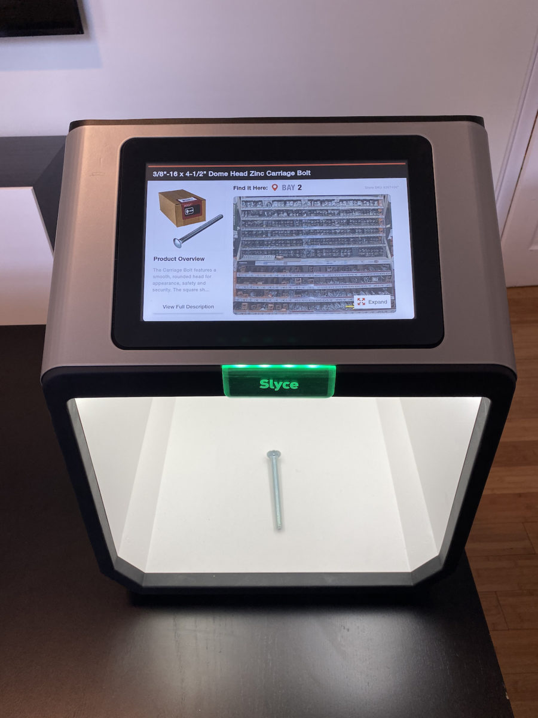

# ****Visualizer****

Take a picture of a room and change flooring, tiles, garage doors

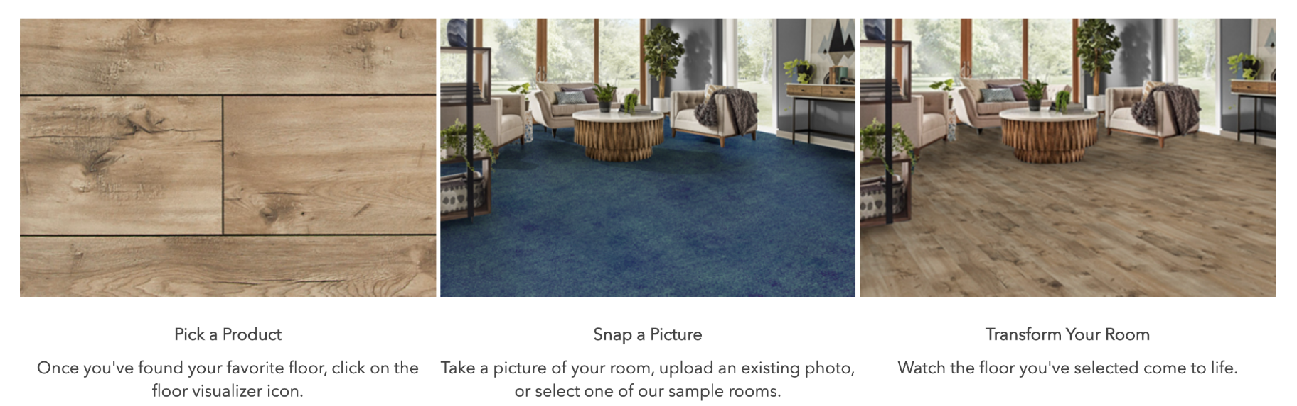

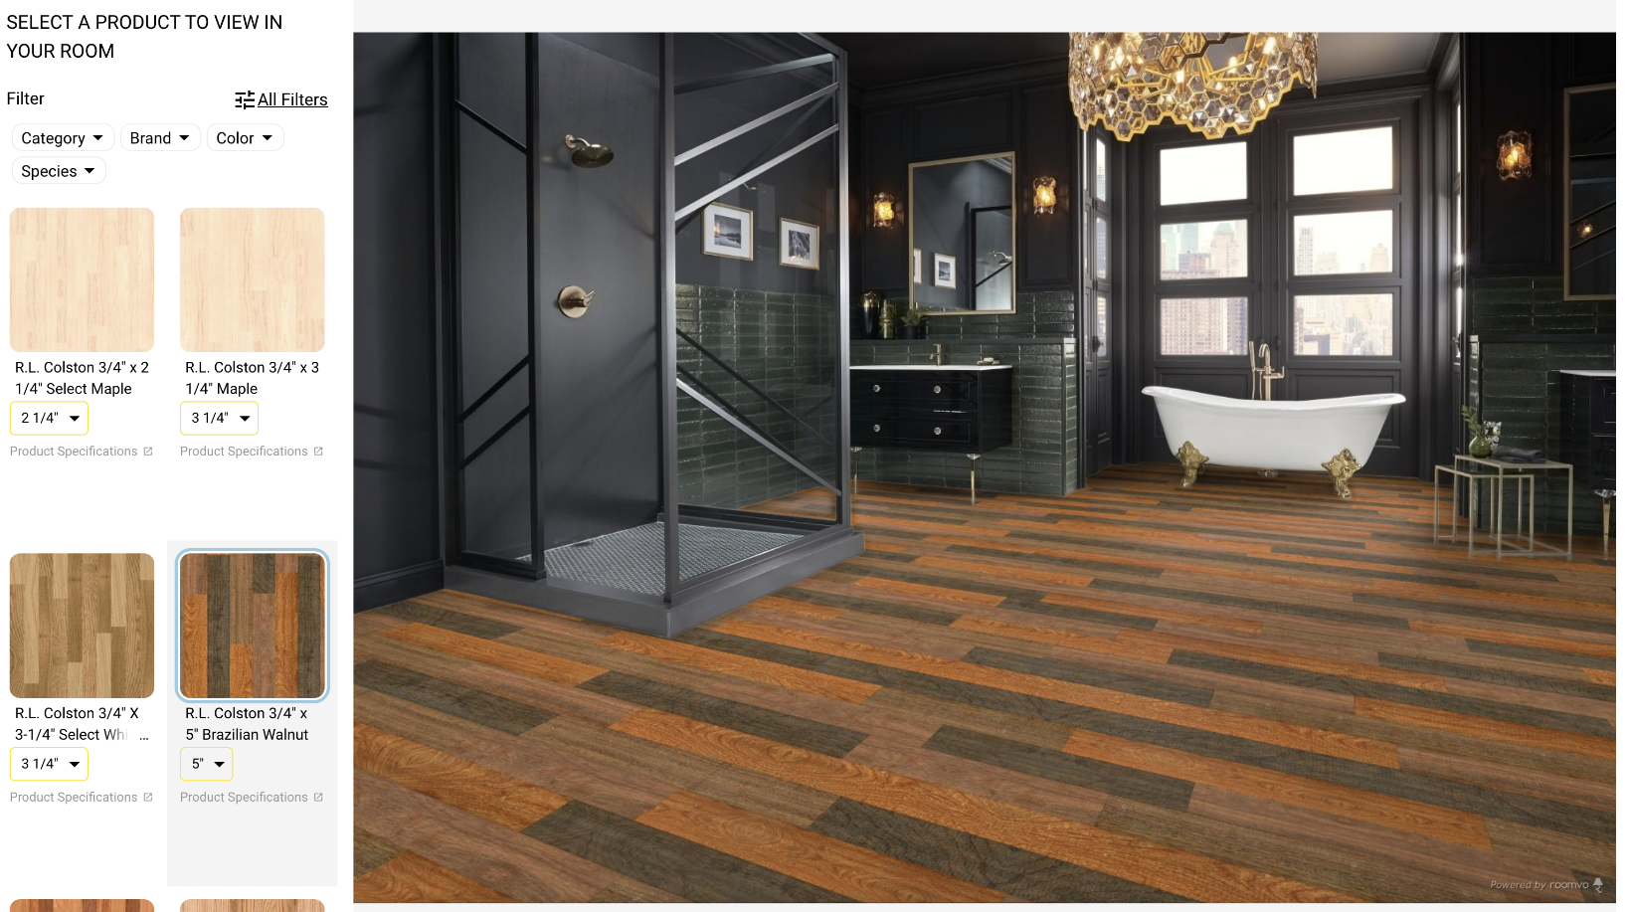

**Examples:**

<https://www.lumberliquidators.com/ll/flooring/floorvisualizer>

2. Garage Door

**Examples:**

<https://myonsite.amarr.com/DoorApp/designer.php?id=AmarrDoorDesigner>

<https://www.amarr.com/>

# ****Content AR****

1. Personalized Lifestyle Images
2. Room scene images
3. Fitting appliances
4. Upgrade Room
   1. Add new furniture
   2. Remove existing furniture

# ****In-store****

1. Aisle and Bay Visits, Impressions, Conversion
2. Aisle and Bay inventory checks

## ****Lowe's Corporate****

1. Assist in price matching through image comparison with competitors
   1. Currently we're only able to match on SKU ~30% of the time to get competitor pricing matching
2. Identify when new items are launched without appropriate images
   1. Sometimes vendors include a stub image "coming soon" or something to that effect
3. Clean up product catalog images
   1. Duplicate images on same product
   2. Duplicate images across products

[Like](https://tools.lowes.com/confluence/display/DSH/Computer+Vision+Use+Cases)Be the first to like this

* No labels
* [Edit Labels](https://tools.lowes.com/confluence/display/DSH/Computer+Vision+Use+Cases)

Top of Form

Write a comment…

Bottom of Form

* Powered by [Atlassian Confluence](http://www.atlassian.com/software/confluence) 7.4.4 (lxappconfprd001: d7430be6)

* [Report a bug](https://support.atlassian.com/help/confluence)

* [Atlassian News](https://www.atlassian.com/company)

[Atlassian](http://www.atlassian.com/)